**How to create a folder in GitHUB**

1. Login to your GitHUB account.
2. Create one public/private repository.

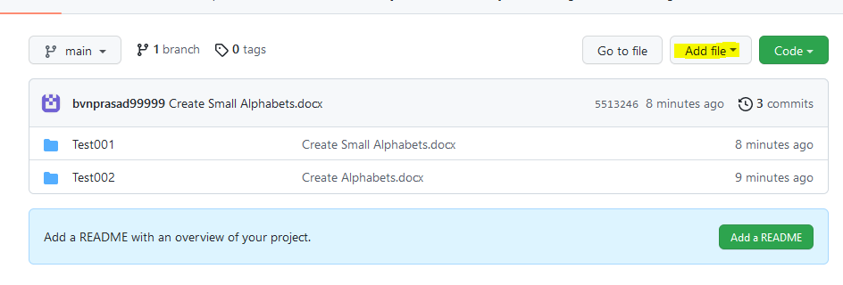

1. Click on Add File.
2. Under Add File click on Create New File as shown in the below figure.

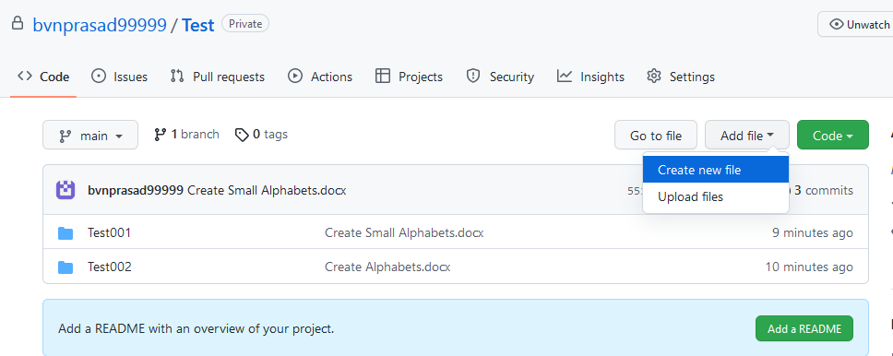

1. You will see the above screen.
2. Type Name as shown in the below figure.

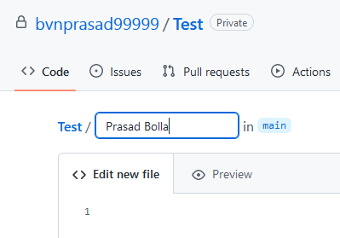

1. After Prasad Bolla type /, so that you will get the folder with name Prasad Bolla.
2. Now provide the filename as shown in the below figure.

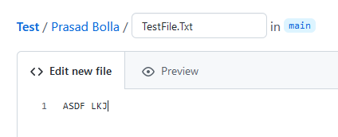

1. Now go to the end of the page.
2. Now click on Commit New File as shown in the below figure.

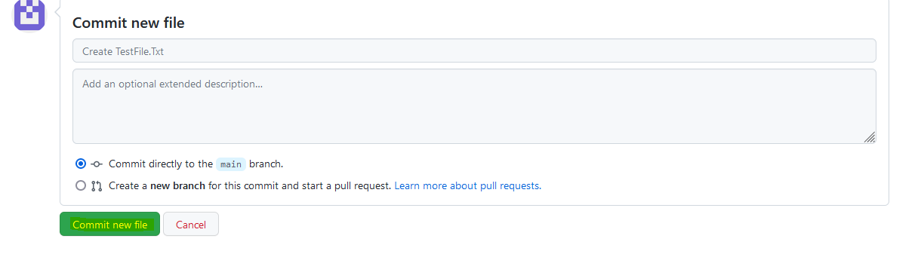

1. Now we see that Prasad Bolla folder was created along with File.

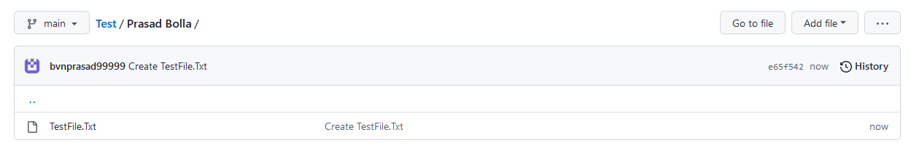

1. Now click on Test link in the above figure.

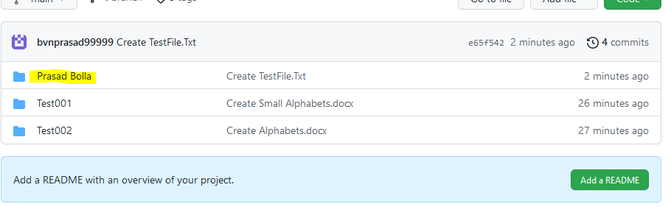

1. You can see Prasad Bolla folder was created.
2. Now click on Respective folder and create files.
3. For creating sub folder under Prasad Bolla follow same process.